Objective: Solve AI search problems using Graph Search Algorithms..
----------------------------------------------------------------------------------------------------------
Explanation:
Maze Representation:
● The maze is represented as a list of lists (a 2D grid).
● Each inner list represents a row.
● '#' indicates a wall.
● ' ' indicates an open path.
● 'S' is the starting point.
● 'E' is the ending point.

Example: Tree Expansion for Maze Search
Assume a simple maze grid (S = Start, E = End):
#####
#S #
# #E#
#####

BFS/DFS Exploration Tree (from 'S' at (1,1))

(1,1) S
|
+-- (1,2)
| |
| +-- (1,3)
| |
| +-- (2,3) E
|
+-- (2,1)

Explained:
- The root node (1,1) is the start position 'S'.
- Possible moves:
  - Right to (1,2), then right to (1,3), then down to (2,3) (which is 'E').
  - Down to (2,1), but from there only wall or already visited positions are possible.

BFS Path:
- Explores all neighbors at each "layer"—would reach (2,3) through (1,2), (1,3) as shortest.

DFS Path:
- Could go deep along one path: e.g., from (1,1) to (1,2), then to (1,3), and finally to (2,3).

Visual Outline (Text Tree)
S (1,1)
|
+-- Right -> (1,2)
| |
| +-- Right -> (1,3)
| |
| +-- Down -> (2,3) [E]
|
+-- Down -> (2,1)

- BFS/DFS both expand nodes like a tree rooted at start, each branch showing a possible move.
- For BFS, all nodes on each level are explored before going deeper.
- For DFS, a full branch is explored as far as possible before backtracking.
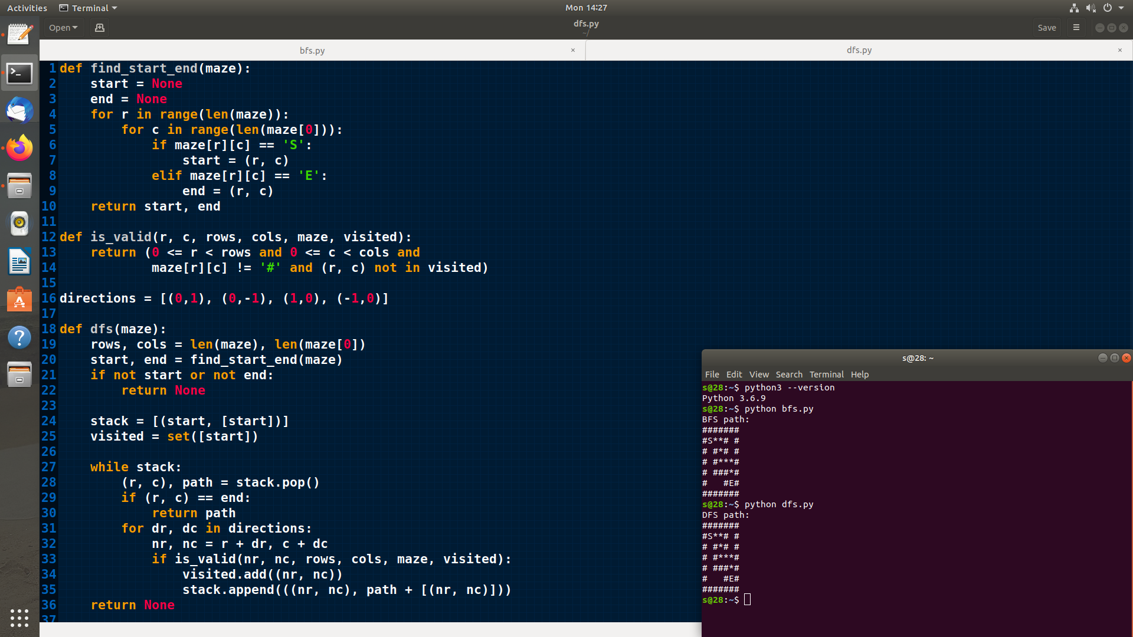
This tree structure helps visualize how AI search algorithms traverse decision points in a maze.

